How to adjust starting position :
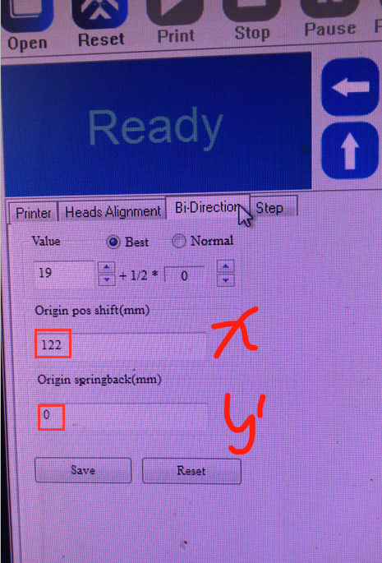
X axis : 1=1mm
Y axis : 5=1mm

If you can not adjust y axis position in printmon ,
you should adjust “config 修改程序.exe ”

1.delete “config--” before you adjust “config 修改程序.exe ”
2.adjust to “25” and check printing start position .

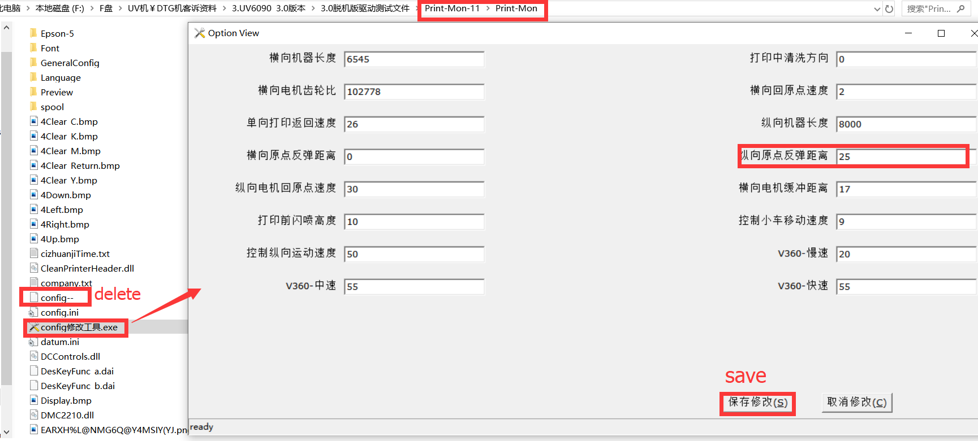

For example:
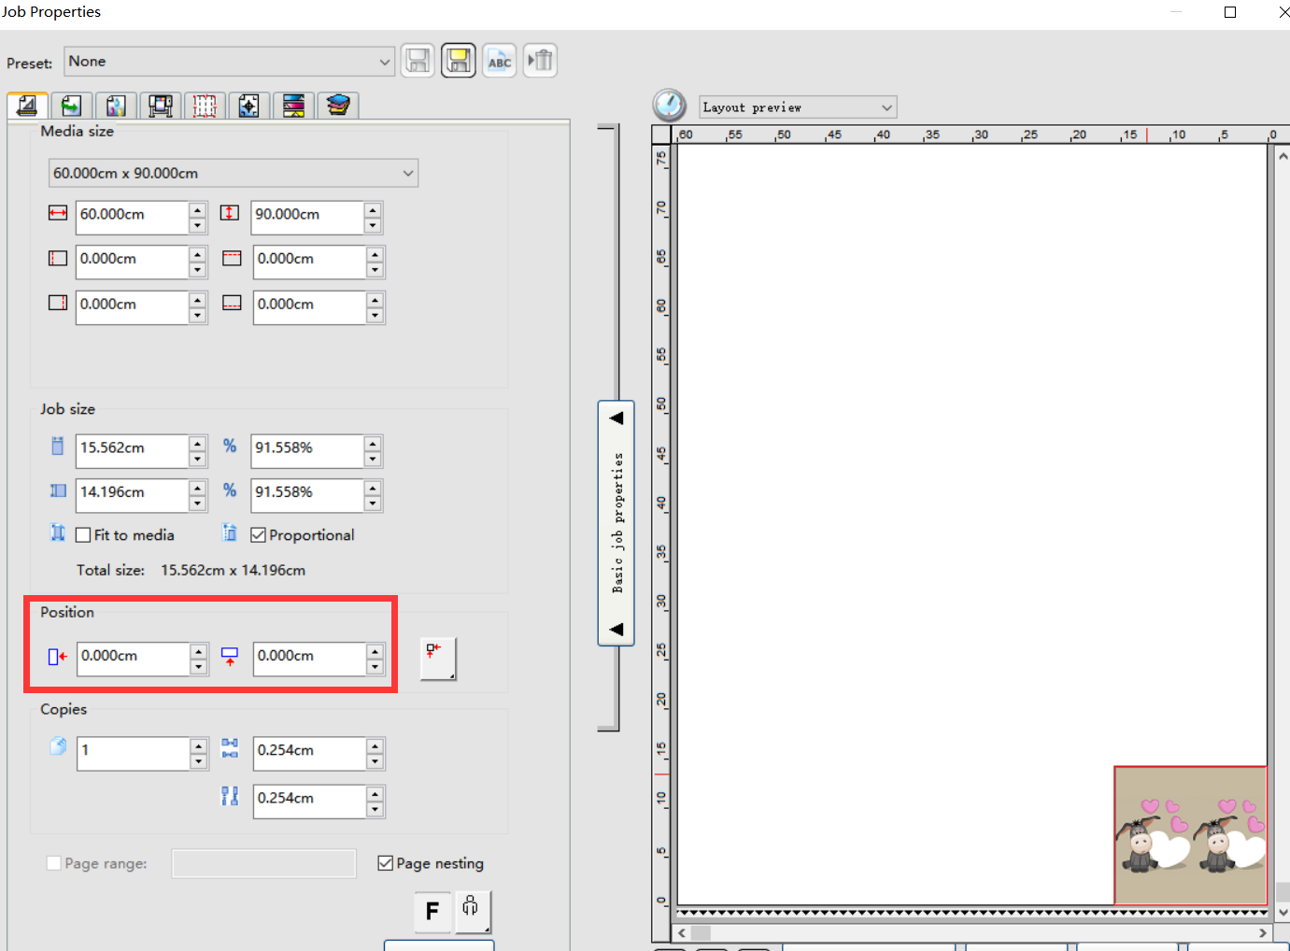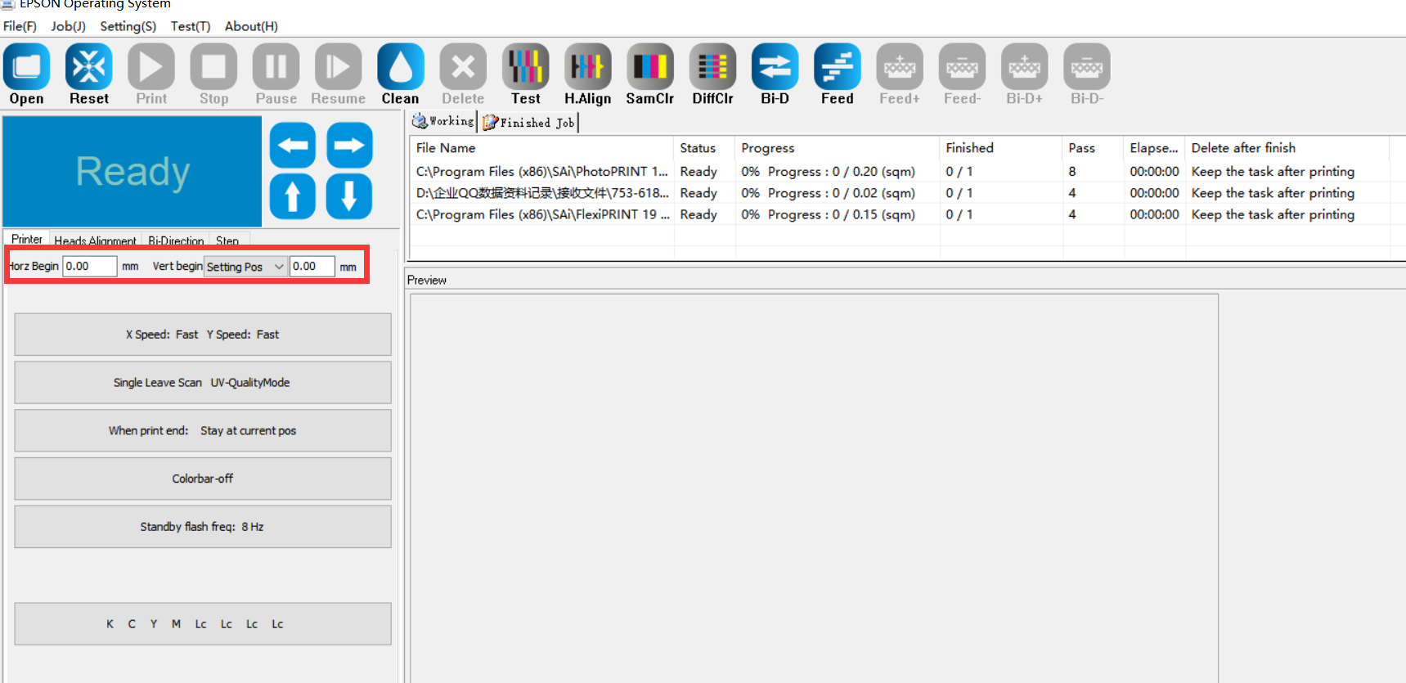
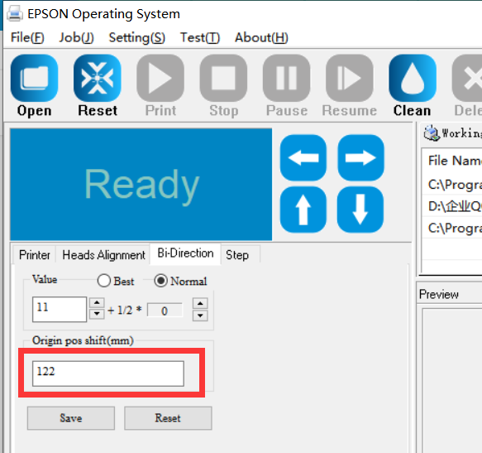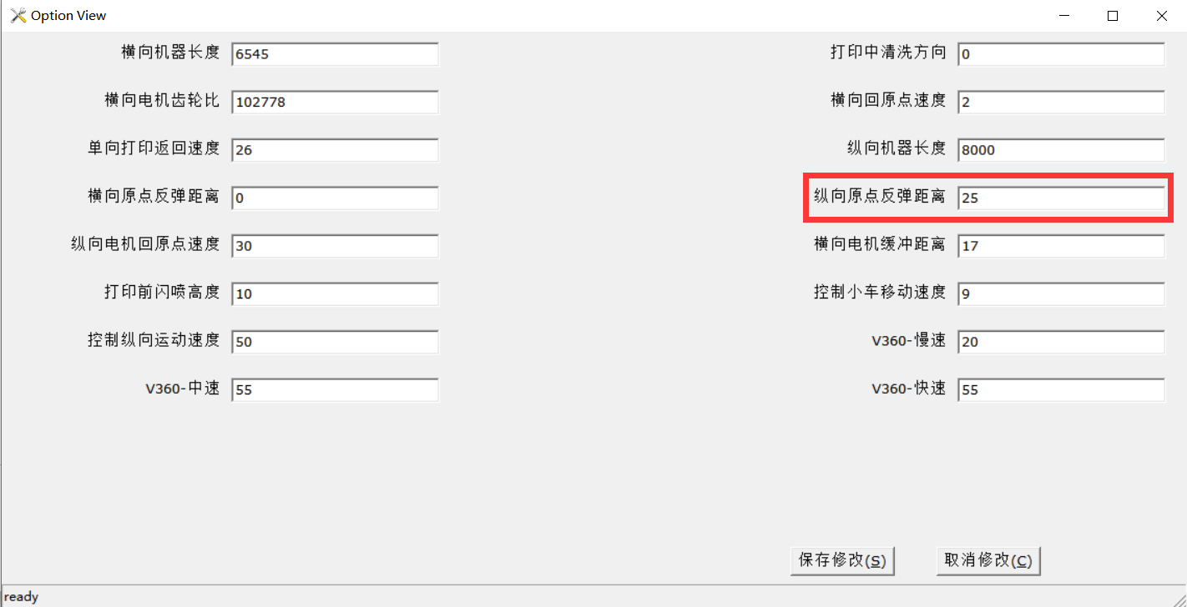
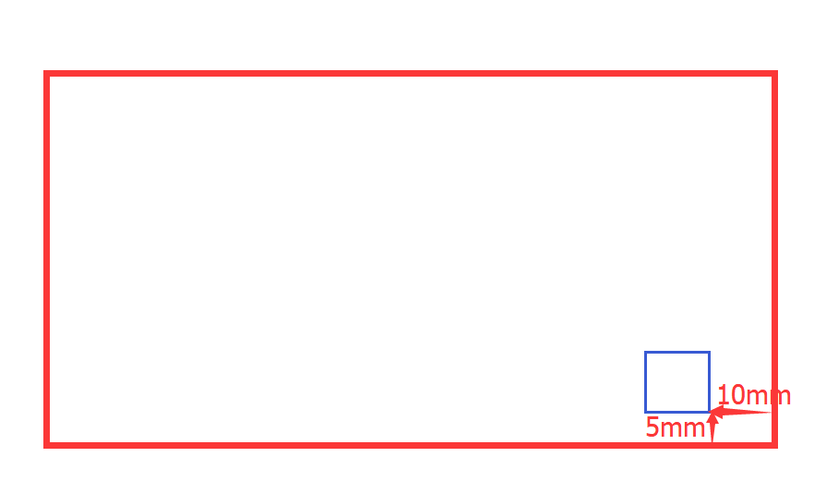
Print an image with start position is (0,0), but the real start position is (10,5).
So we change the value to:
122-10*1=112
25-5*5=0

