5IN1 MUG PRESS MACHINE
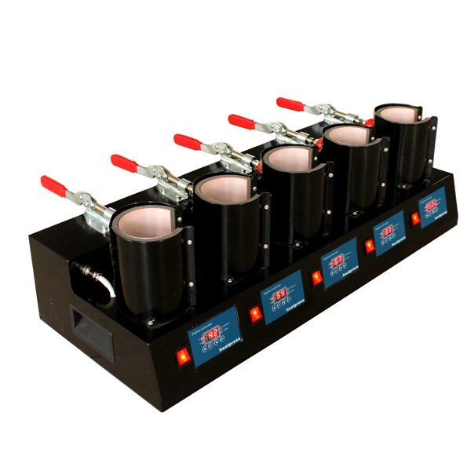
Operator’s Manual (CE)

This machine is not suitable for minors to use or food processing.
• General:
The Mug Press is a great tool for applying your digital images onto coffee mugs, travel mugs, beer steins,
and more. Set up and print a digital image onto transfer paper using your favorite image manipulation
software program, and then use the Mug Press to heat and transfer the image onto the substrate. The main
benefits of the Mug Press is how quickly the image is transferred, the easy-to-use digital control panel and
thumbscrew pressure adjustments.

1.Set temperature
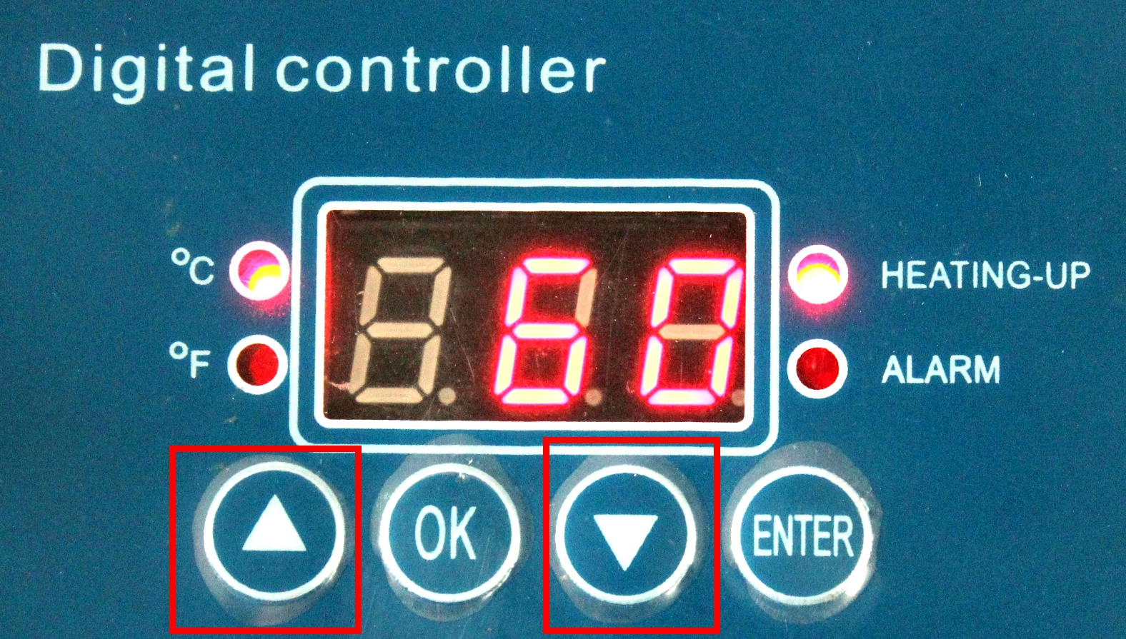  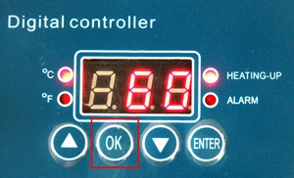 | 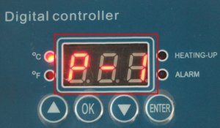 | 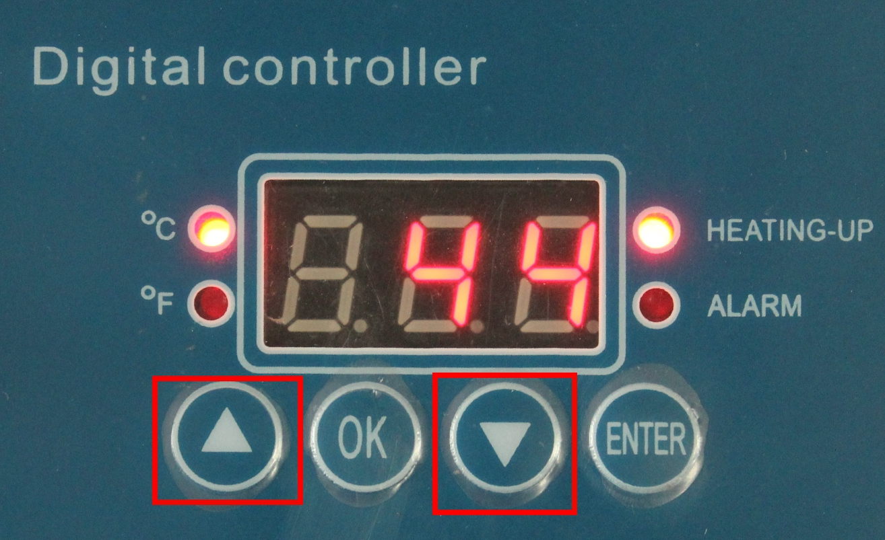
Press OK button | The display show P-1 | Press arrows “△”or “▽” adjust temp you need
- Set time
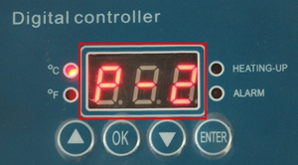 |  | 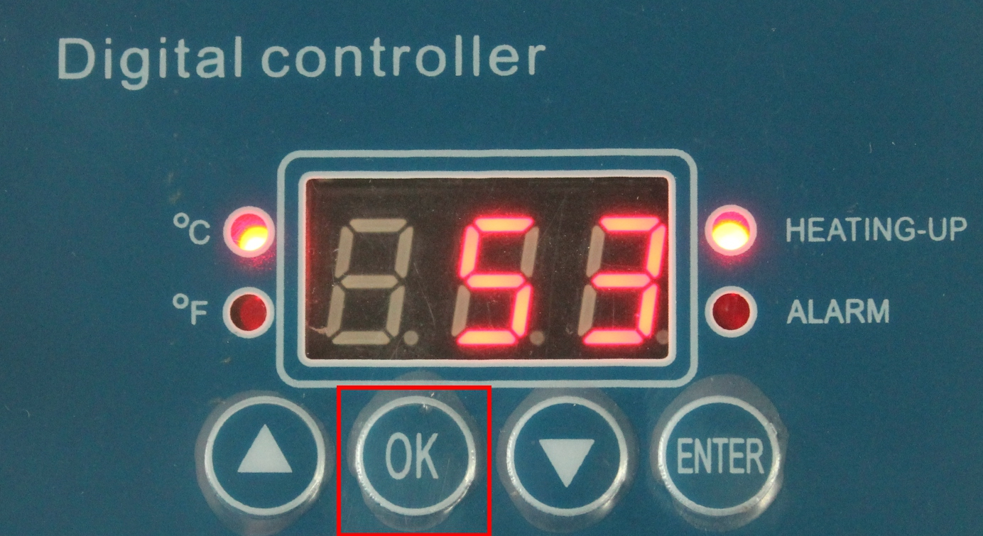
Press OK button after setting temp,display show P-2 | Press arrows “△”or “▽” adjust time you need | Press OK button after time setting

Printing process:
- Clean the mug surface,cut the image as per your design,printing size about height 9cm,length 20cm
- Wrap the mug with the cut image，Make the image in the central and make it symmetrical both sides；Stick the paper with thermal tape.
- Put the mug in the center of heating mat
- Adjust the pressure ball for printing mugs, not too tight, or too loose and close the handle.
- Turn on power and adjust the time about 200S-300S，temp gauge about 180℃-200℃.
- The machine will sound an alarm automatically when reaching time,turn off power for each heating mat, take out the mug from the heating mat
- Peal off the paper. Put the mug S L O W L Y into cool water,then see a photo mug is well done by yourself!

.Pls don't heating without any mug in the heating mat
 | Problem | Reason | Solution
1 | No display after powering up | Poor outlet contact, or  the fuse is blown. | Change the power cable and  check outlet. Replace fuse with the supplied backup fuse.
2 | Fails to heat up or do not heat up to the temperature displayed. | The heating pad is  burnt out. | Check heating pad  connections. Replace the  heating pad.
3 | Lack of color, faded image. | Insufficient temperature  and/or press time. | Adjust the temperature  and/or increase the heating time.
4 | Darkened, deep color; blurred image. | Pressed for too long,temperature too high | Adjust the temperature and  heating time.

