CAP PRESS MACHINE
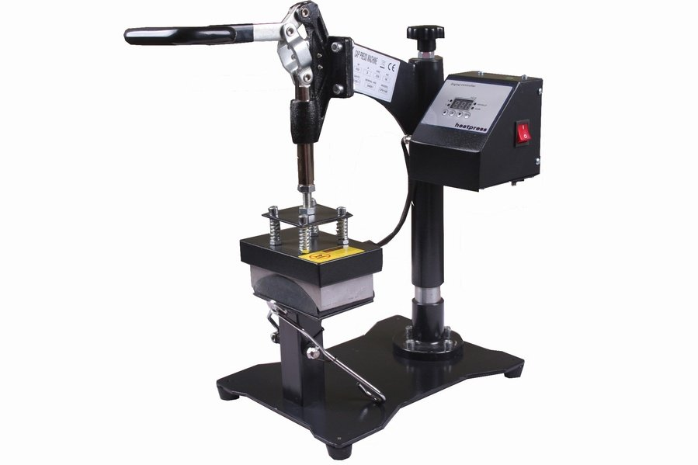
Operator’s Manual (CE)

This machine is not suitable for minors to use or food processing.
• General:
It will help you to leave the beautiful and clear picture on cap. So do not hesitate. Cap press machine will transfer the picture printed out on cap easier and faster. The picture is not only clear and vivid, but durable.
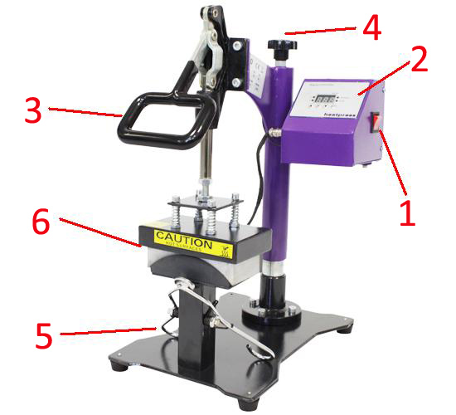
.•Components and functions:
①power switch
②digital controller
③handle
④pressure adjust knob
⑤cap holding device\
⑥heating board

1.Set temperature
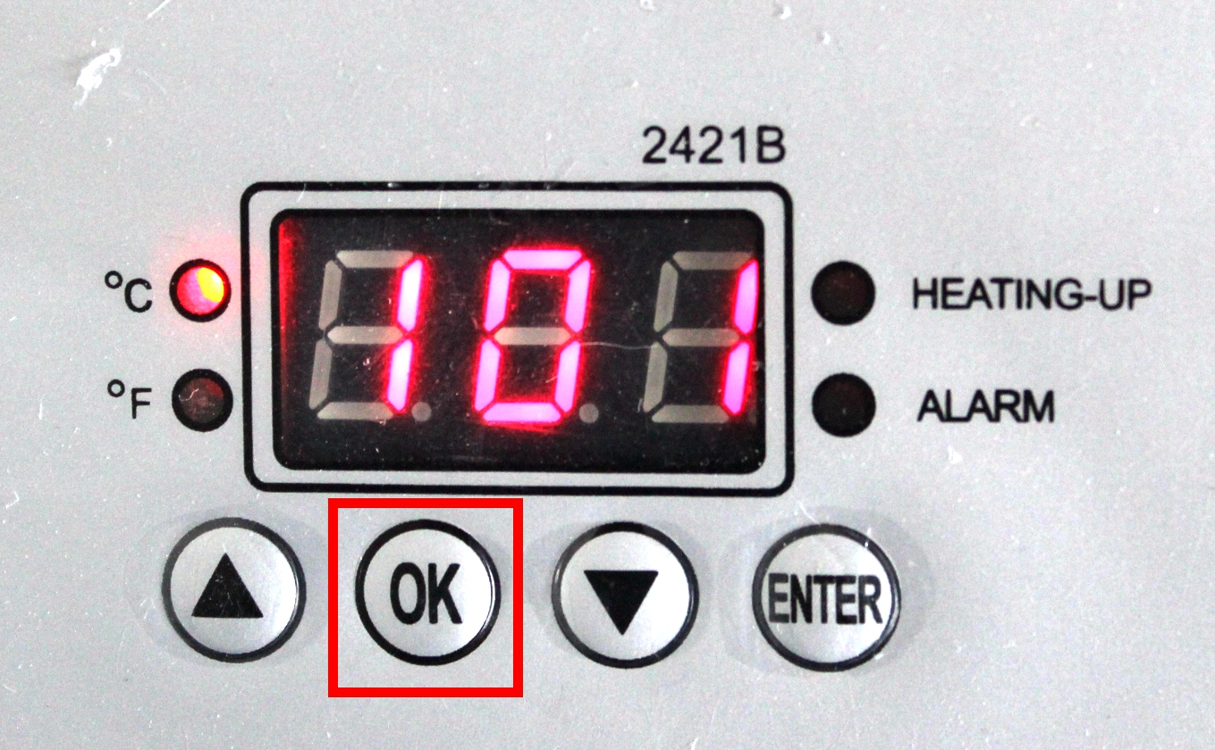 | 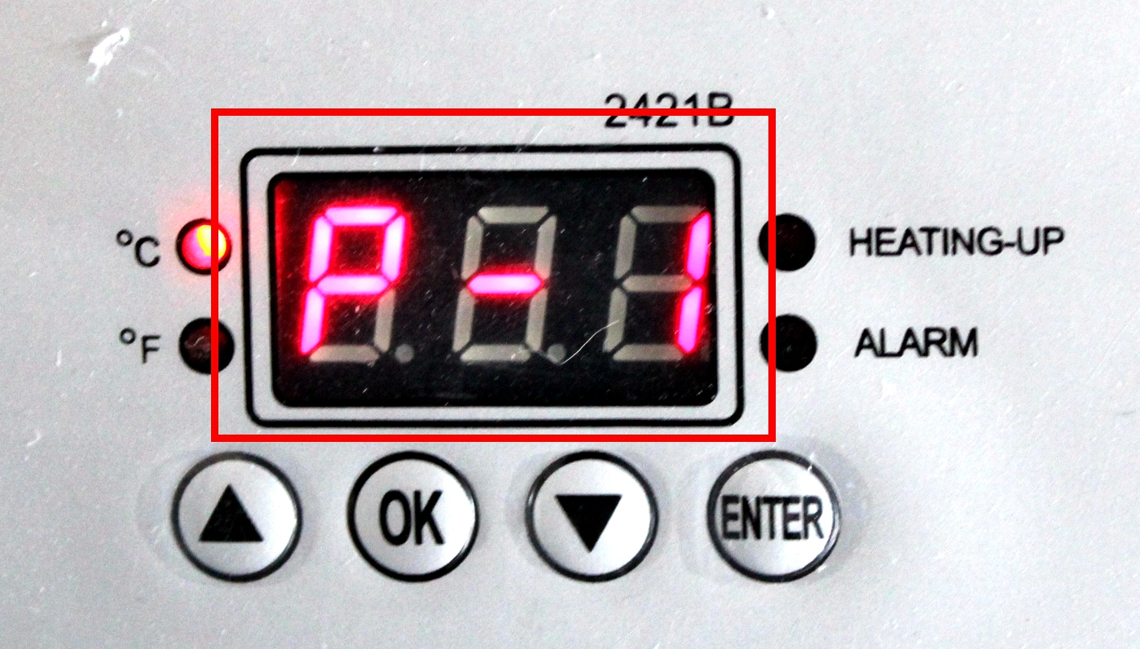 | 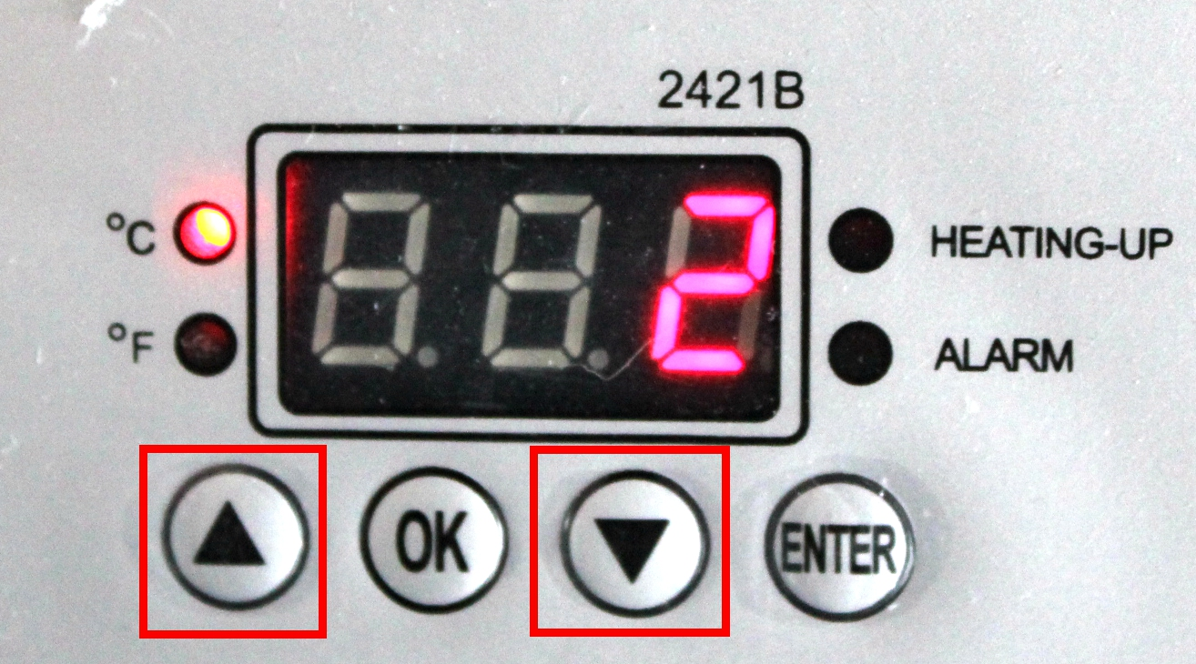
Press OK button | The display show P-1 | Press arrows “△”or “▽” adjust temp you need
- Set time
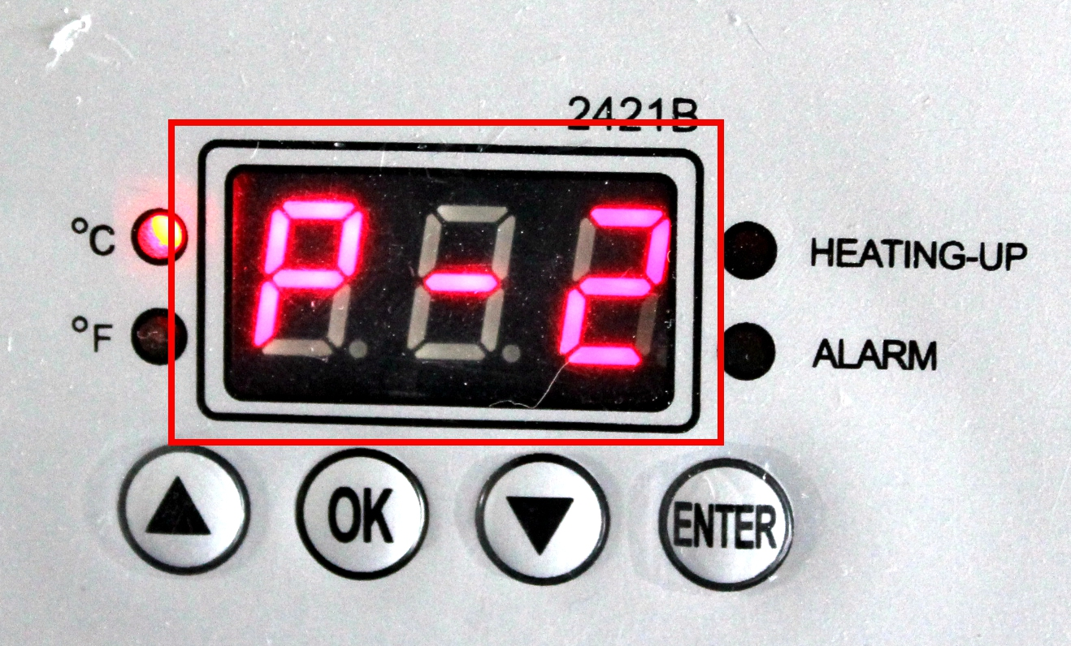 | 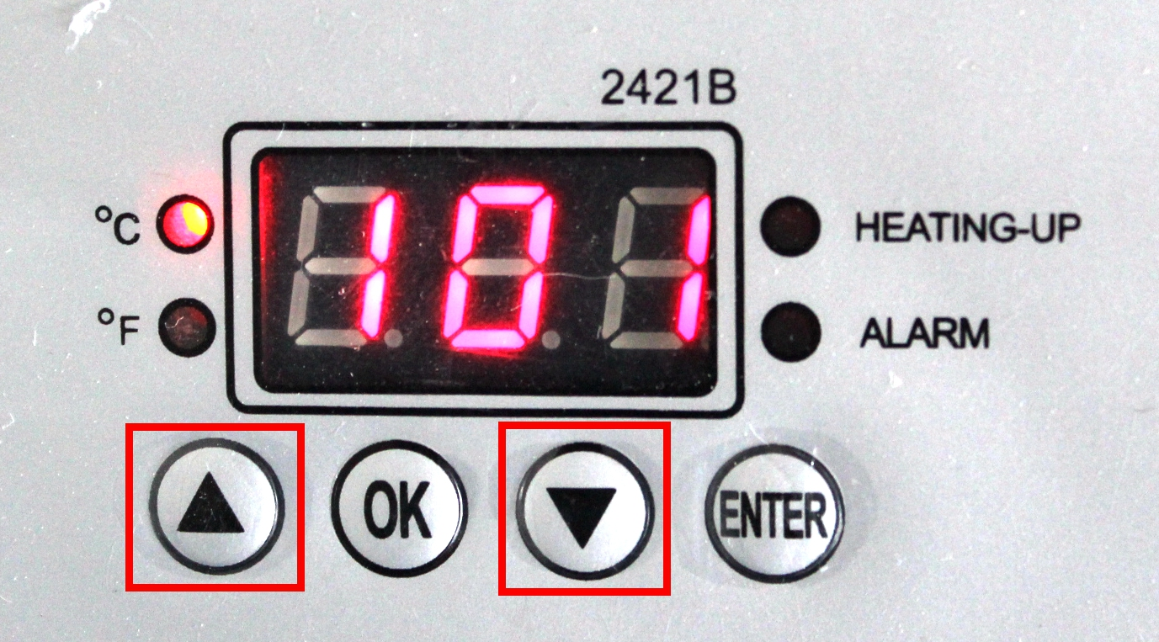 | 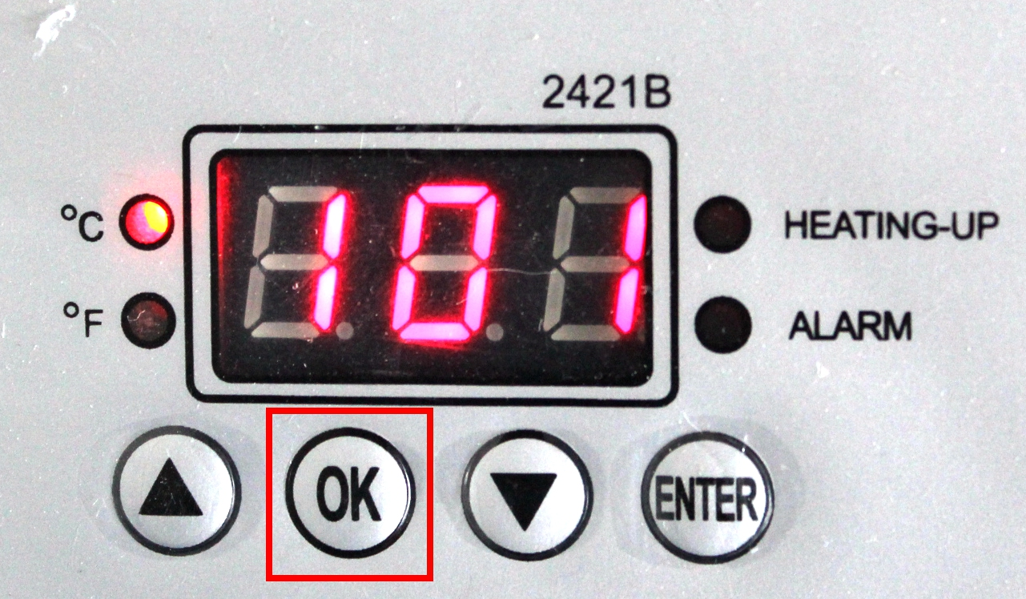
Press OK button after setting temp,display show P-2 | Press arrows “△”or “▽” adjust time you need | Press OK button after time setting

- Clean the cap surface,cut the image as per your design.
- Stick the cut image on cap with thermal tape.
- Put the cap on the working table,hold the cap firmly with Device (5).
- Adjust suitable pressure with screw (4), not too tight, or too loose.
- Turn on power (1) ,adjust the time/temp gauge (2) about 30S-40S，temp gauge about 180℃-200℃.
- When the heating board (6)reach temp set,close the Handle (3), the machine will sound an alarm automatically when reaching time,turn off power (1), take out the plate.
- Peal off the paper then see a photo cap is well done by yourself!
Note: Pls try a small sample to get the right temp and time needed before large quantities printing.

 | Problem | Cause | Handling methods
1 | No display after powering up | Poor outlet contact, or  the fuse is blown. | Change the power cable and  check outlet. Replace fuse with the supplied backup fuse.
2 | Fails to heat up or does not heat up to the temperature  displayed. | The heating pad is  burnt out. | Check heating pad  connections. Replace the  heating pad.
3 | Lack of color, faded image. | Insufficient temperature  and/or press time. | Adjust the temperature  and/or increase the heating time.
4 | Darkened, deep color; blurred image. | Pressed for too long,temperature too high | Adjust the temperature and  heating time.

