HEAT PRESS MACHINE HP230B

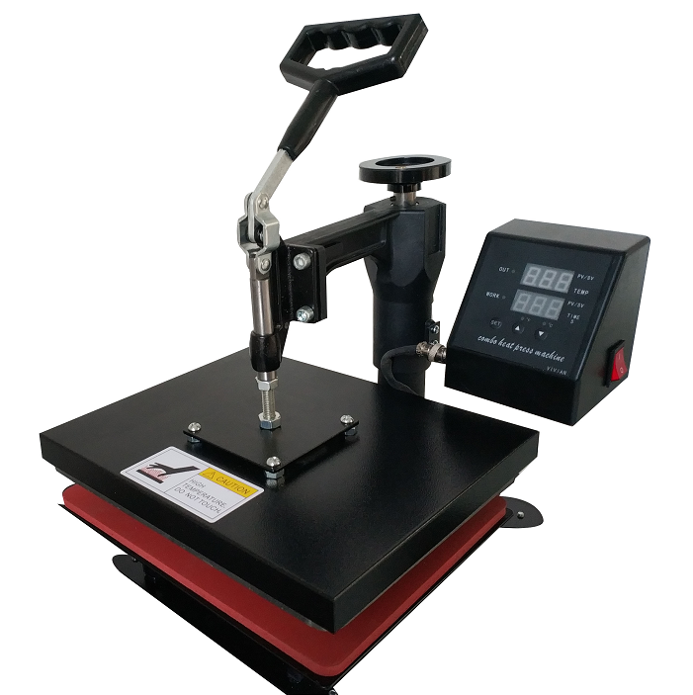

**Operator’s Manual (CE)**

**This machine is not suitable for minors to use or food processing.**

* General:

A heat press machine is the machine that presses a transfer onto an imprintable substrate. Using high temperatures and pressures for a certain amount of time, the transfer is permanently embedded into the product.

Heat presses are recommended for professional and satisfying

results simply because standard laminating devices and home

hand irons can not get even near the temperatures required for a

reliable transfer.

*Components and functions:

@ Place the material on working table,adjust the pressure knob(3) get right pressure required

@ Connect power plug and turn on power button(1)

@ Set time & temp you want with temp/time gauge (2) get required numbers.

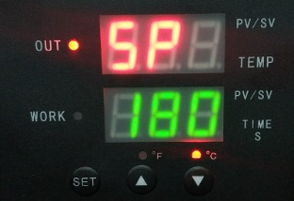Setting:

Temperature setting:

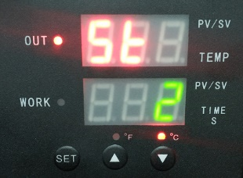Press “SET”key, upper display frame shows “SP”; lower display frame shows temperature values, press ▲ or ▼ to increase or decrease temperature.

Time setting:

Double press “SET”, upper display frame show ”S ”, lower display frame shows time, press ▲ or ▼ to increase or decrease time

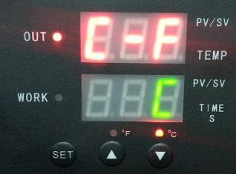Centigrade /

Fahrenheit conversion:

Press “SET”3 times, upper display frame show “C-F”, lower display frame shows temperature units, press ▲ or ▼ to increase or decrease to convert between centigrade and Fahrenheit

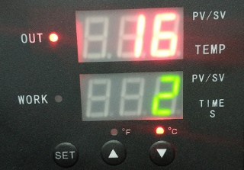start the countdown：

In the interface shown in the picture, press ▼ to start the countdown.

**Note: 1. Because the materials and thickness of these materials are different,so the temp and time also**

**2. Pls try a small sample to get the right temp and time needed before large quantities printing.**

**3. Clothing require temp about 180°C/356℉, Fabric clothing use with sublimation paper:30-50 sec, 100% cotton clothing use with transfer paper: 15-20sec.**

