PLATE PRESS MACHINE
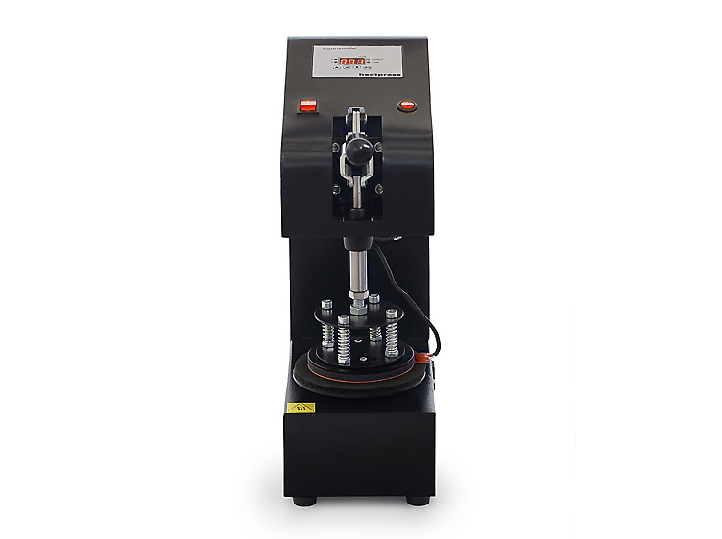
Operator’s Manual (CE)

This machine is not suitable for minors to use or food processing.
• General:
It will help you to leave the beautiful and clear picture on the ceramic plate we provide you. So do not hesitate. Plate press machine will press the picture printed out on ceramic plate in two minutes. The picture is not only clear and vivid, but durable.
.•Components and functions:
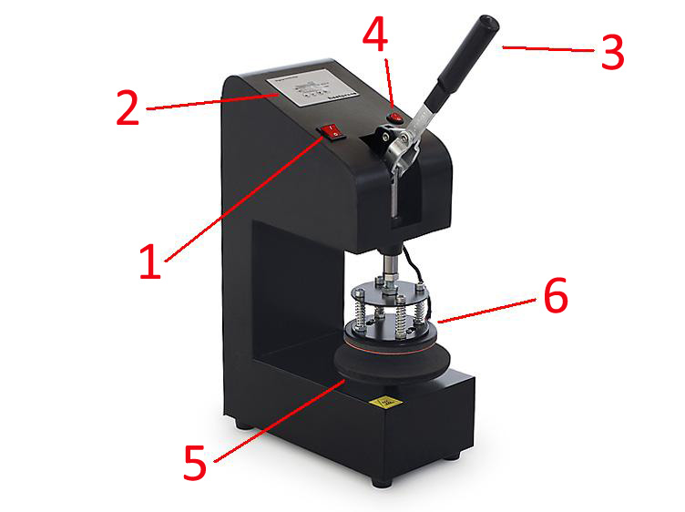
- Clean the plate surface,cut the image as per your design.
- Stick the cut image on plate with thermal tape,make the image in the central.
- Put the plate on the working table (5)
- Circumvolve the working table(5)adjust suitable pressure, not too tight, or too loose.
- Turn on power (1) ,adjust the time/temp gauge (2) time about 120S-180S，temp about 180℃-200℃.
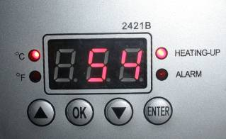
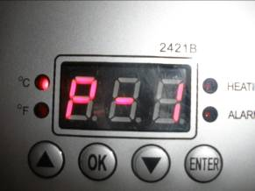
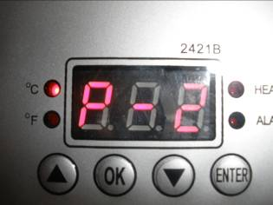

Press”OK”,P-1 for temp Press”OK”,P-2 for time Press”OK” turn back
- When the plate heating mat (6)reach temp set,close the Handle (3) and press Start Button (4) or ENTER button on gauge(2),the machine will sound an alarm automatically when reaching time,turn off power (1), take out the plate.
- Peal off the paper. Put the plate S L O W L Y into cool water,then see a photo plate is well done by yourself!
Note: If you want to print another plate, just turn on the machine, needn’t adjust the time, but just adjust the pressure, make sure it same as the first one.

1.Pls turn off for several minutes (let machine cool) every hour or so.
2. Pls try a small sample to get the right temp and time needed before large quantities printing.

 | Problem | Cause | Handling methods
1 | No display after powering up | Poor outlet contact, or  the fuse is blown. | Change the power cable and  check outlet. Replace fuse with the supplied backup fuse.
2 | Fails to heat up or does not heat up to the temperature  displayed. | The heating pad is  burnt out. | Check heating pad  connections. Replace the  heating pad.
3 | Lack of color, faded image. | Insufficient temperature  and/or press time. | Adjust the temperature  and/or increase the heating time.
4 | Darkened, deep color; blurred image. | Pressed for too long,temperature too high | Adjust the temperature and  heating time.

