**HEAT PRESS MAHCINE INSTRUCTION**

**HP380****4C**

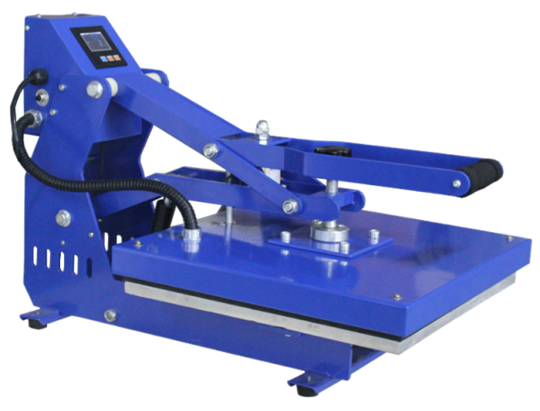The press is equipped with a manual override, a digital display, and a sound signal at the end of work.

Our company makes easy and quick adjustment of pressure as a function of the print at any time.

Designed for printing textiles and other materials may be used on food, t-shirts, mouse pads, puzzles, ceramic tiles, and other flat surfaces items by using the flex, flocking, transfer printing paper, sublimation etc.

**comply with these instructions**

1. Do not put the wire on heating plates cover.

2. Do not touch heating plates when it is energized.Caution: Risk of burns.

3. Do not open the machine box and make changes to the device.

4. Do not allow liquid or metal objects inside the hot press.

5.Make ensure the machine is connected with a plug connected to the mass.

6. Don't pull the cable to disconnect the plug.

7.Power off he machine when finish using.

8. Use extreme caution when using near children.

9.Make sure that the device is used in an environment.

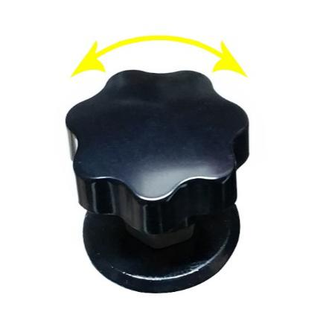**1.SET PRESSUREN**

1.1.Adjust pressure at the top of the tray in a clockwise direction to increase pressure and in the opposite direction to decrease by turning the knob.

**2.SET TEMPERATURE &TIME**

(Blue means temperature, white means time)

2.1.Press on the on / off switch located on the side of the heat press to be energized.

2.2.Press once on the "SET", screen show "SP" on the display. Press “▼”or “▲” to the desired temperature.

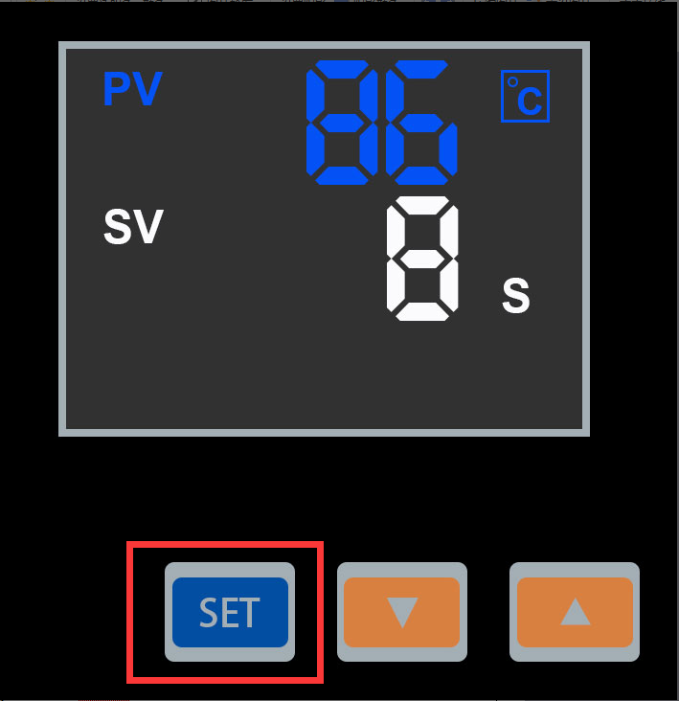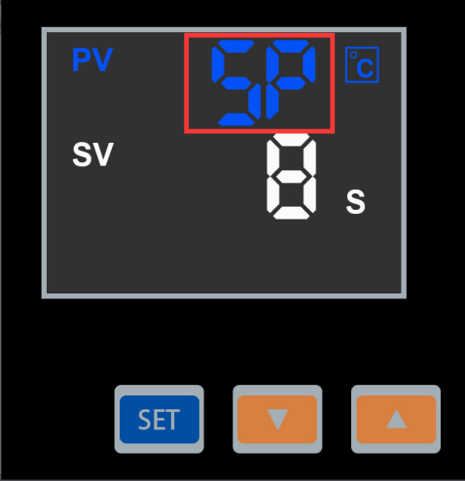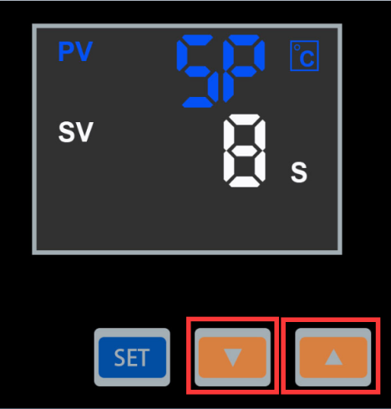

① ② ③2.2.Press once again on "SET", screen show "St" on the display.

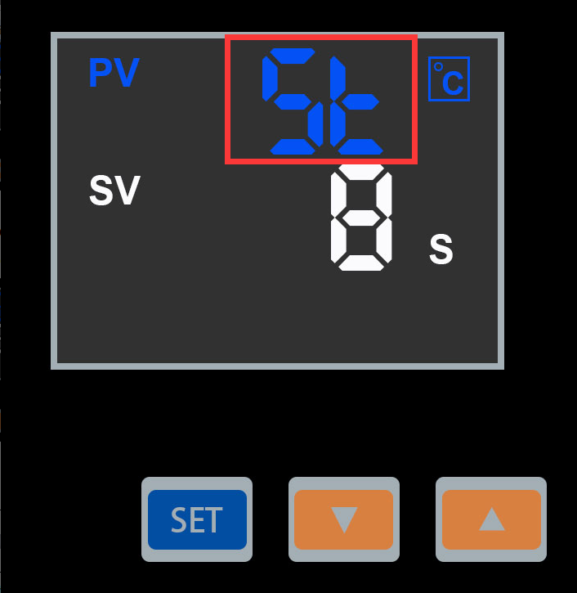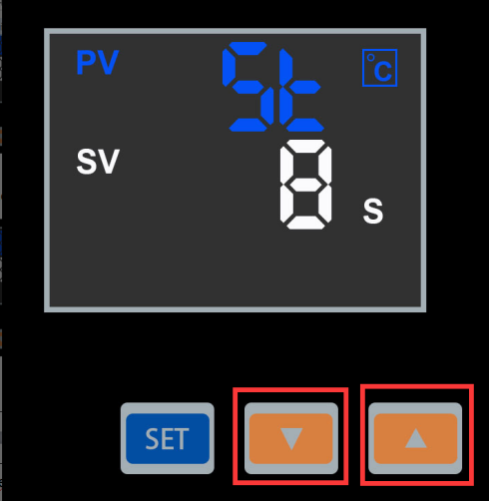Press “▼”or “▲” to the desired time.

④ ⑤ ⑥

2.3.Press “SET” again after finish all setting to come out setting mode.

2.4.Put objects when the machine has reached the desired temperature, close heating plates, waiting time.

2.5.When times up, machine will ringing and open automatic, take out printing items.

**3.Common Problem：**

|  |  |  |  |
| --- | --- | --- | --- |
|  | Problem | Cause | Handling methods |
| 1 | Picture burning | Too much time or temp | Adjust time or temp. |
| 2 | Fails to heat up,but display well | Heating plate or Relay broken | Check the heating plate or Relay |
| 3 | Lack of color, faded image. | Insufficient temperature  and/or press time. | Adjust the temperature  and/or increase the heating time. |
| 4 | Darkened, deep color; blurred image. | Pressed for too long,temperature too high | Adjust the temperature and  heating time. |
| 5 | No action after turn on power | Plug whether touch well  Fuse whether burn | Check the plug and fuse |
| 6 | The real temp pass over setting temp | Relay broken | Replace the relay |

1. **For cleaning and maintenance of the printed products.**

4.1.Printed items can be washed 24 hours after printing.

4.2.Do not rub the printed image after printing.

4.3.Frequently wash items by washing machine can damage the image.

4.4.Avoid using cleaner or brush image.

4.5.Do not expose in the sun too long.