**Dual-Display Heat Press Machine**

Digital，double-display，self-clocking

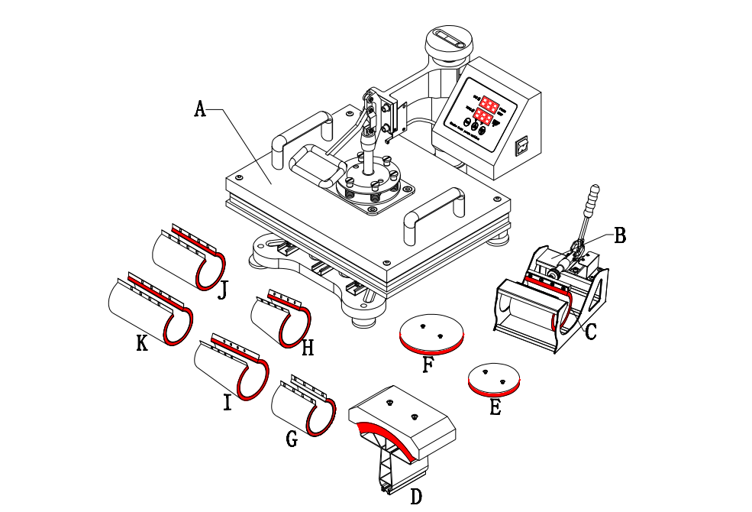**Instruction**

B : Mug Press Machine

C : Mug Press（12*23.5cm）( 11oz )

D : Hat/Cap press：5.5"x 3" （14*8cm）

E : Plate Press #1 5" max diameter （12.5cm）

F : Plate Press #2 6" max diameter （15.5cm）

G : Mug Press 12*19cm

H : Mug Press 12OZ

I : Mug Press 17OZ

J : Mug Press 15*19cm

K :Mug Press 13.5*23.5cm

Dear Customer,

We appreciate your preference on our multi-functional heating press machine. Our patented rail combination heating press machine is one of the most outstanding ones in this world.

Controlled by microprocessor and designed with key-touching control panel, our heating press machine features high accuracy and easy operation. Sliding rails make components replacement simpler. Advanced design and technologies offer convenience for upgrade and after-sales service.

Features:

1. Revolutionary sliding rails make components replacement easier.

2. Auto timer & alarming clock

3. Digital dual displays are controlled with microprocessor, which brings higher accuracy.

4. Stable power offers intensive protection for circuit board

5. The new-generation thermocouple is safer and sturdy.

6. Thickened aluminum board brings even capacity. Superior quality and construction are guaranteed.

7. 360° swivel design for easy transport.

8. Place a heat-resistant silicone rubber foam mat on the base, and the base can withstand up to 752°F without deformation.

Specification:

Heating Plate size: 29*38CM /1000W 38*38CM/1000W

Package Size: 46.5*50*42.5CM 55*48.5*42.5CM

Voltage: 110v 220v

Temperature Range: (0 – 250℃) / (0-482℉)

Timer: 0 - 999 S

5in1 6in1

Heating Plate Heating Plate

Cup Press + Large Cup Press Mat Cup Press + Large Cup Press Mat

Hat Press + Hat Press Pad Hat Press + Hat Press Pad

Large Plate Press Pad Large Plate Press Pad

Small Plate Press Pad Small Plate Press Pad

Small Plate Press Pad

8in1

Heating Plate

Cup Press

Large Cup Press Pad

Hat Press + Hat Press Pad

Larger Plate Press Pad

Small Plate Press Pad

Small Cone Plate Pad

Large Cone Plate Pad

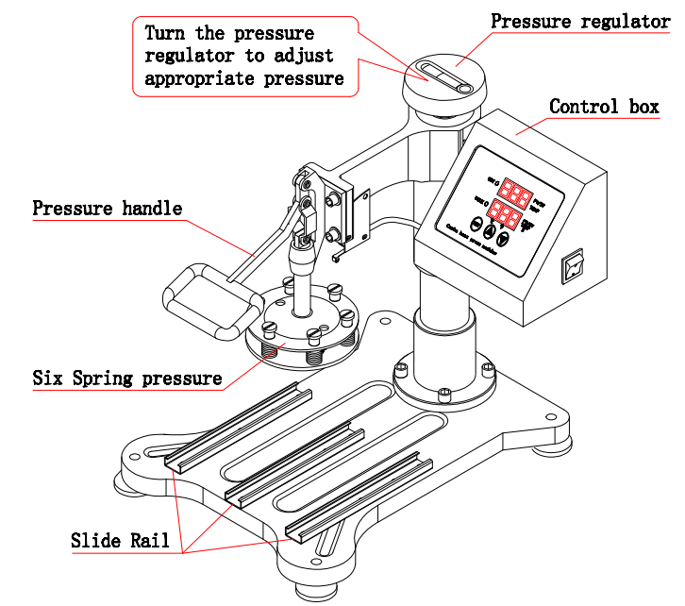

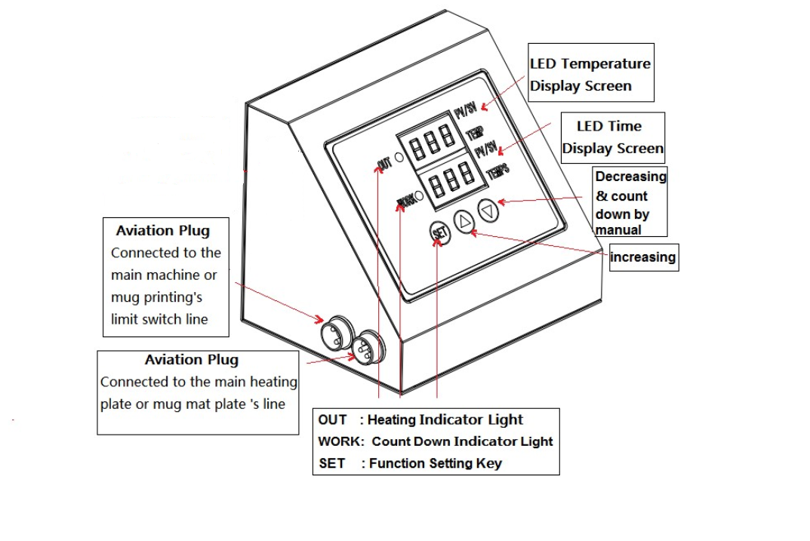

Operation Instruction

Controller

OUT: Heating

WORK: Countdown

SET: Function setting

▲: Increase

▼: Decrease&**（count down by manual）**

Upper display frame: temperature

Lower display frame: countdown

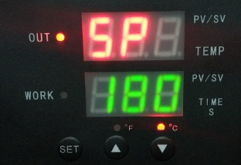Setting:

Temperature setting:

Press “SET”key, upper display frame shows “SP”; lower display frame shows temperature values, press ▲ or ▼ to increase or decrease temperature.

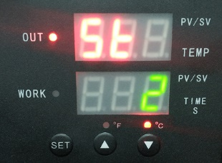Time setting:

Double press “SET”, upper display frame show ”S ”, lower display frame shows time, press ▲ or ▼ to increase or decrease time

Centigrade / Fahrenheit conversion:

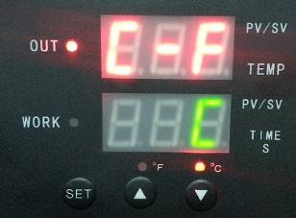Press “SET”3 times, upper display frame show “C-F”, lower display frame shows temperature units, press ▲ or ▼ to increase or decrease to convert between centigrade and Fahrenheit

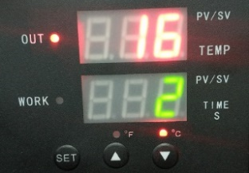start the countdown：

In the interface shown in the picture, press ▼ to start the countdown.

**Note: 1. Because the materials and thickness of these materials are different,so the temp and time also**

**2. Pls try a small sample to get the right temp and time needed before large quantities printing.**

**3. Clothing require temp about 180°C/356℉, Fabric clothing use with sublimation paper:30-50 sec, 100% cotton clothing use with transfer paper: 15-20sec.**

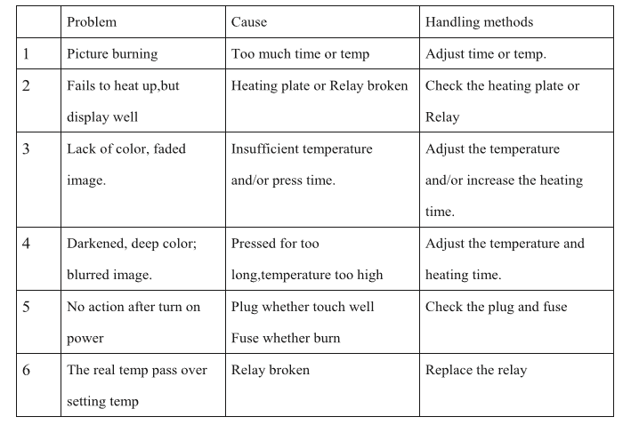

Installation:

Heating Press Machine (for T-shirt)

Pressing Board Installation: push “E”or“F” into the hole and fix them with a screwdriver.

Mug Stamping Installation: secure silicone rubber foam pad on the magnetic rod.

Stamping Installation: secure mug on the mug press “B”

Kindly prompts:

To print and make individualized DIY products, it is also necessary for you to prepare the following equipments and materials.

1. Ink jet printer/ six colors printer (For example: Epson R-230 / R270 / R290 / T50)

2. CISS (Continuous ink supply system)

Different models of Ink jet Printer will need different CISS.

3. Sublimation ink / Heat transfer ink;

4. High-temperature resistant tape;

5. Sublimation paper / Heat transfer paper (for Ceramic and fabric)

6. Paper cutter

7. Press mug / cup and plate: Normal mug and plate will can not use for press, Only sublimation mug and plate can be use.

**Heat Press Machine Users’ Guide**

**Thank you for purchasing our product, we appreciate your business. It is a multi-purpose heat press machine with which you can apply it on T-shirts, caps, china or mugs. However, it does require different attachment to make it compatible with different tasks.**

1. **Attachment for T-shirts**

**The machine is defaulted to T-shirt mode. The default temperature is 356°F while the timer is set to 30 seconds.**

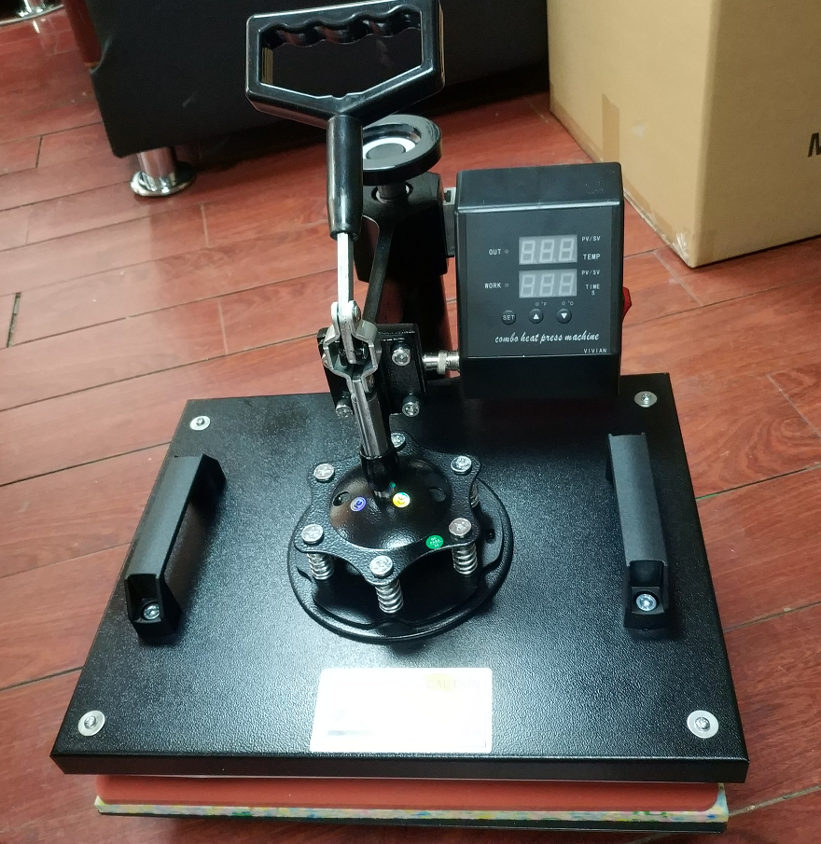

1. **eramic plate installation**

**Remove the screws on the heating plate, insert the ceramic plate back on and secure them to finish heating plate assembly.**

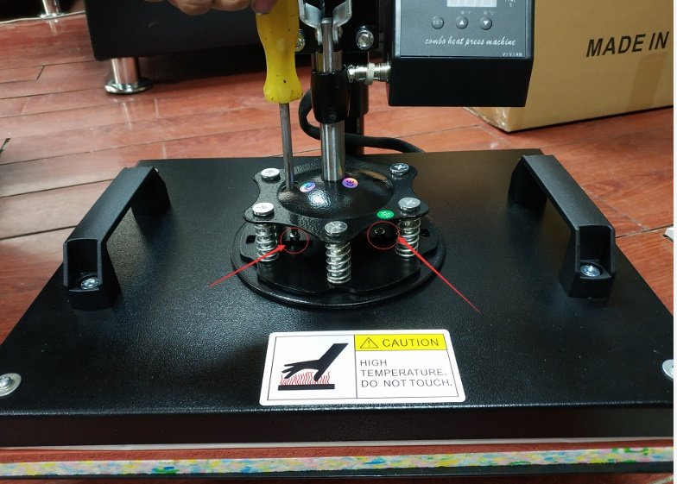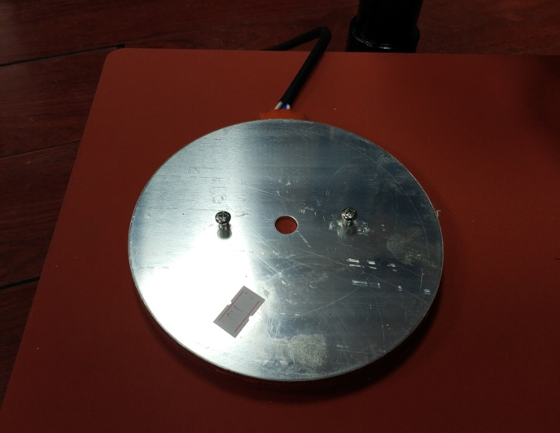

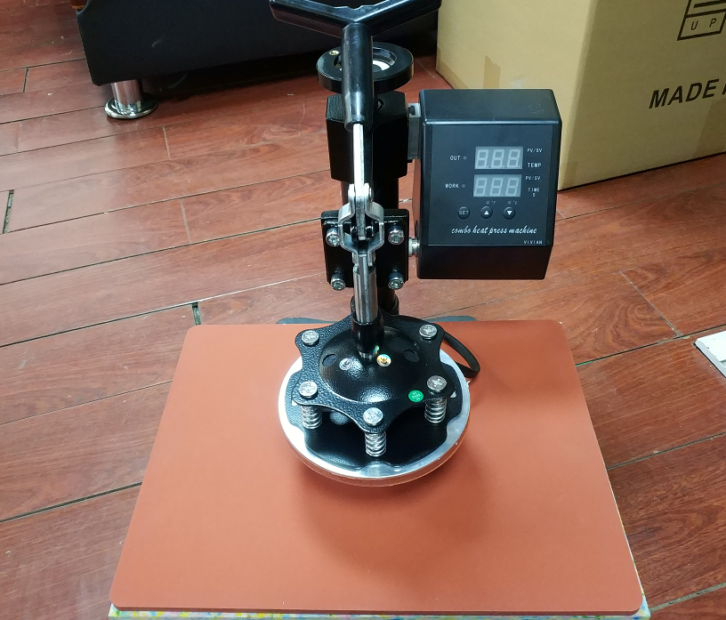

1. **Attachment for caps/hats installation**

**The whole attachment easily slides in/out, after taking out the previous attachment, insert the attachment for caps/hat and slide it in, secure with screws.**

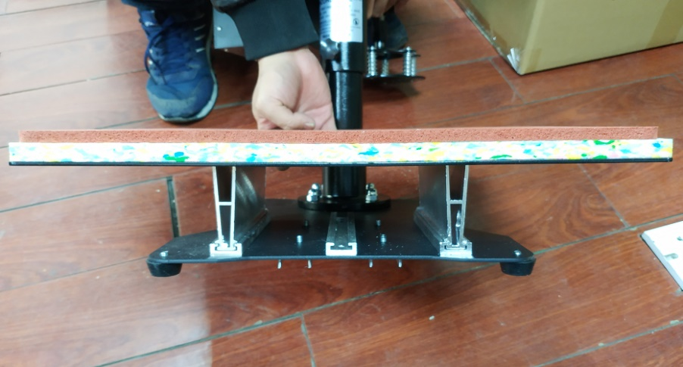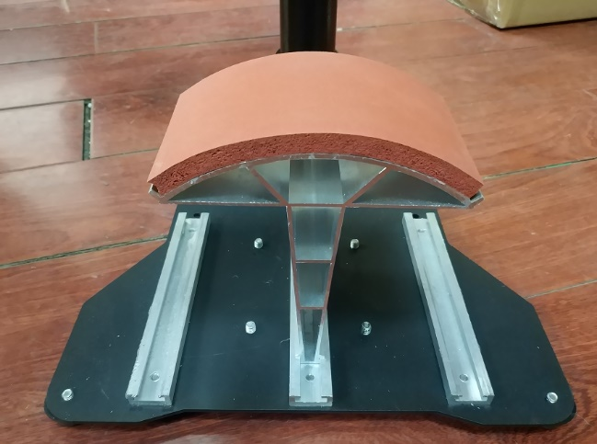

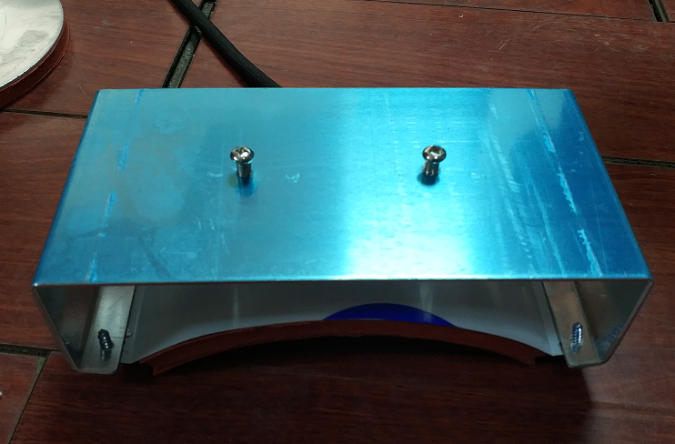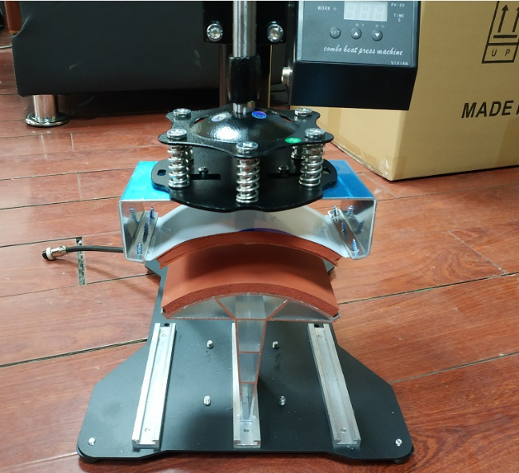

Attachment for caps/hats

1. **Attachment for cups and cylindrical objects installation**

**This particular attachment requires no installation, it is good to use after plugged in with power. If you want to replace the cup, untighten the clamp and replace the cup.**

