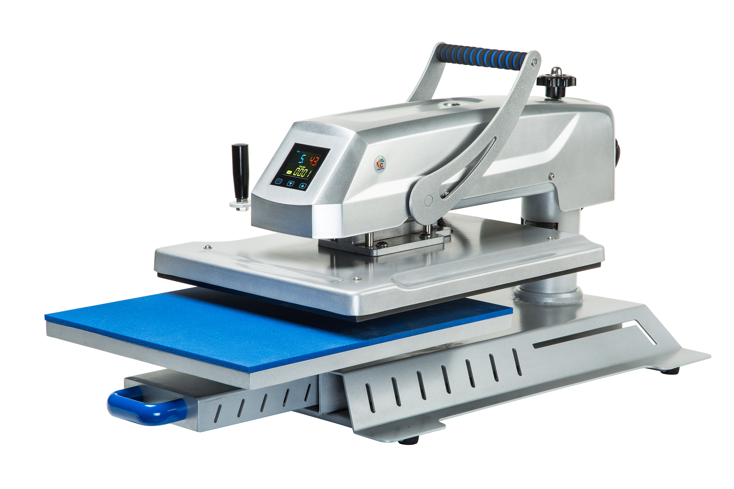
HEAT PRESS MACHINE

Operator’s Manual (CE)

This machine is not suitable for minors to use or food processing.

• General:
A heat press machine is the machine that presses a transfer onto an imprintable substrate. Using high temperatures and pressures for a certain amount of time, the transfer is permanently embedded into the product.
Heat presses are recommended for professional and satisfying results simply because standard laminating devices and home hand irons can not get even near the temperatures required for a reliable transfer.
•Components and functions:
- Place the material on working table,adjust the pressure knob get right pressure required
- Connect power plug and turn on power button
- Set time & temp you want with temp/time gauge get required numbers.

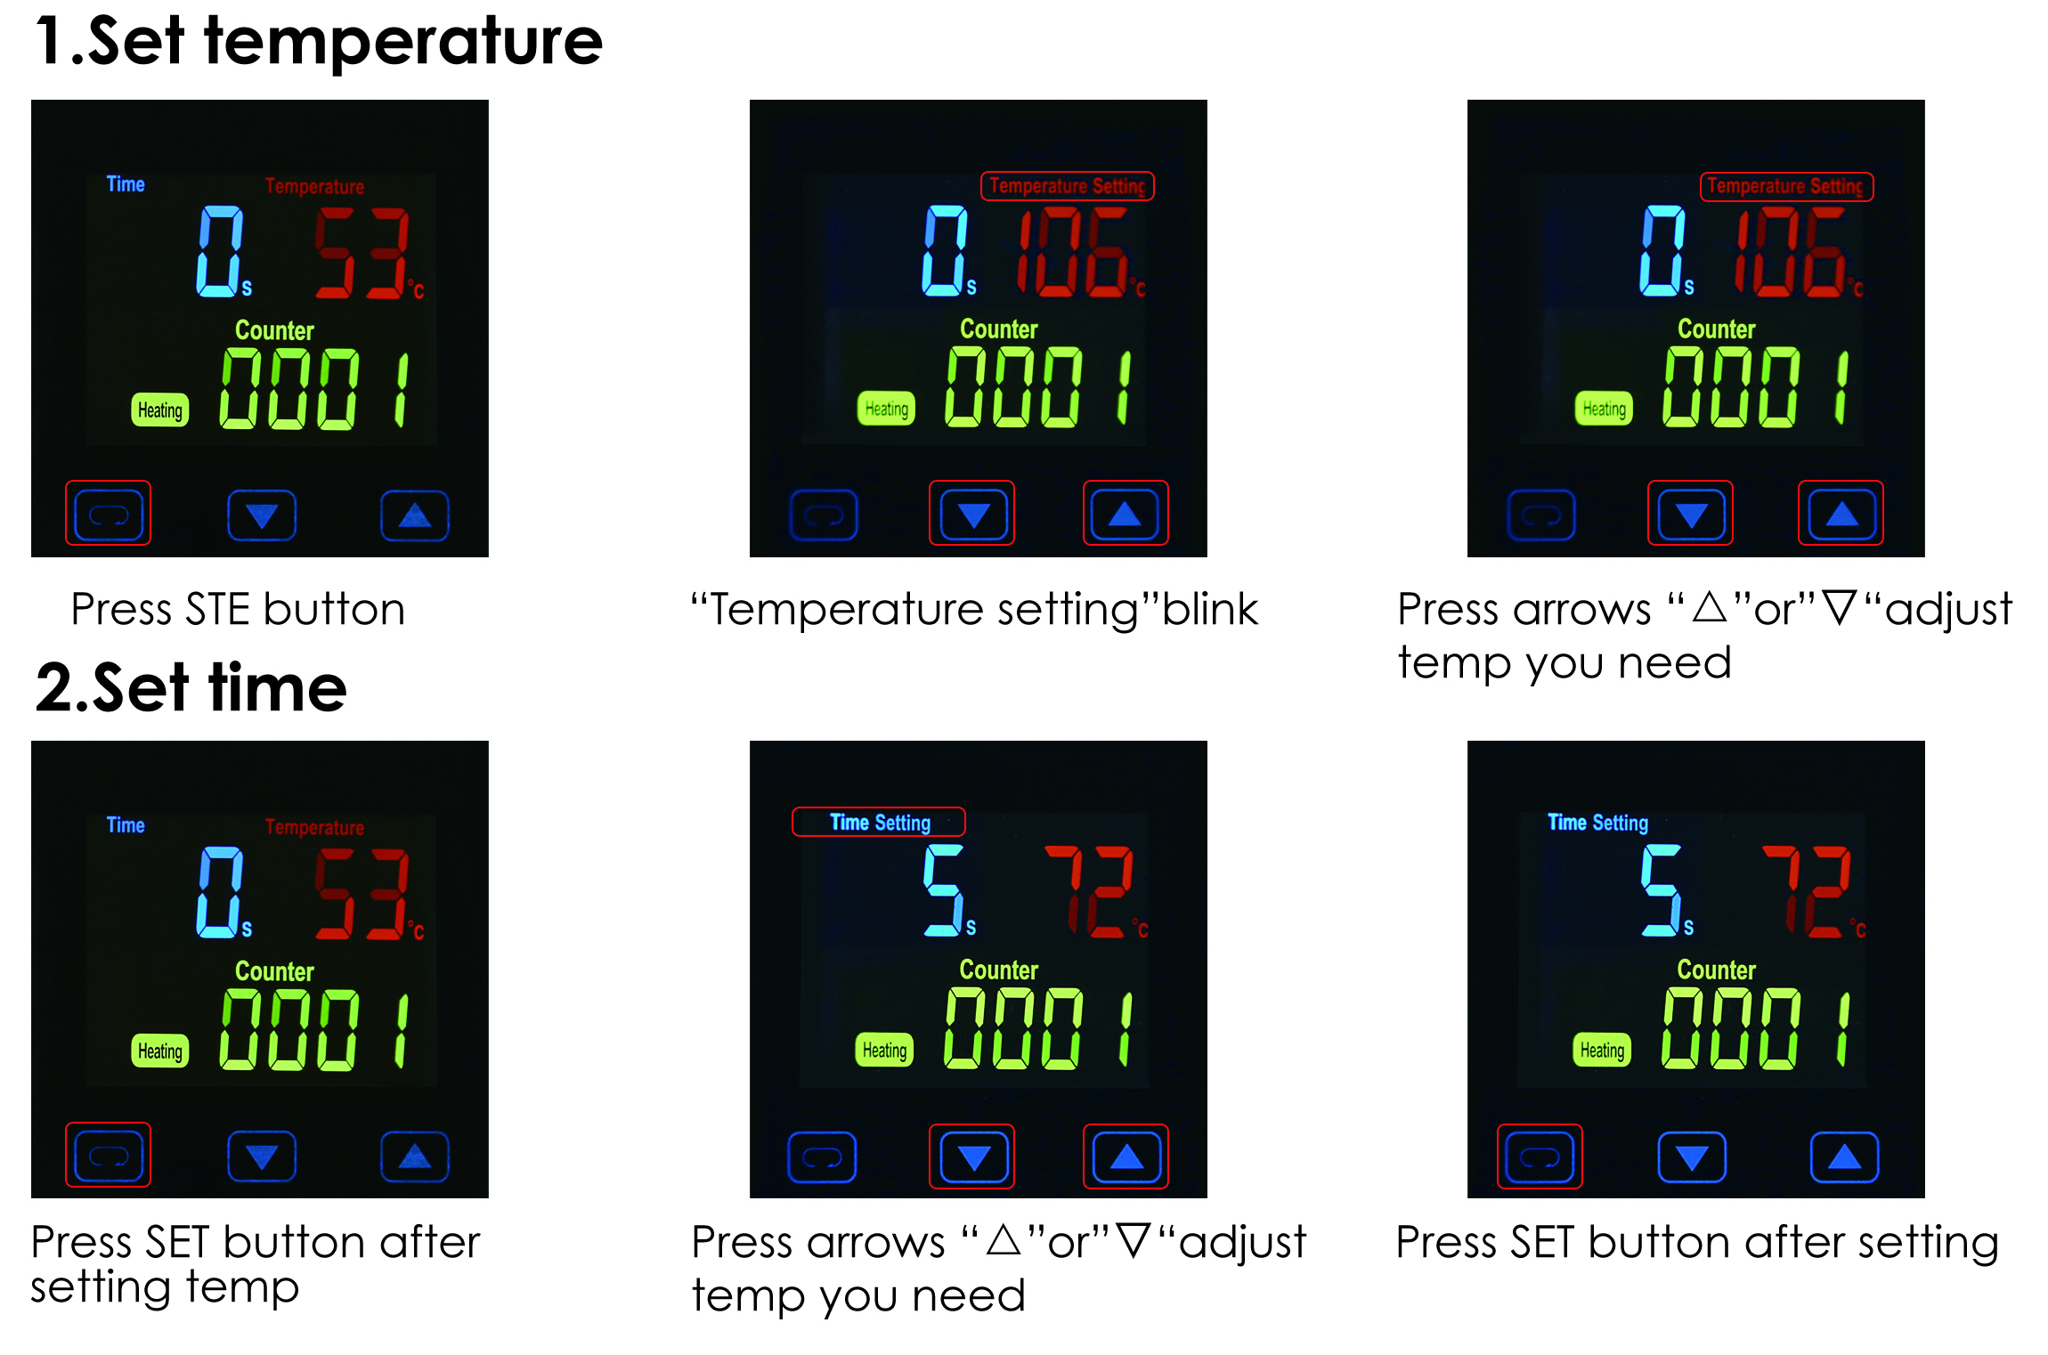

- The temp for heating plate will start to rise up,when it reaching temp you set,place the material on the working table and close the handle
- The buzzer will sound when reaching time you set,release the handle and take out the material


Note:
1.Because the materials and thickness of these materials are different,so the temp and time also required different.
2. Pls try a small sample to get the right temp and time needed before large quantities printing.
3.Clothing require temp about 180℃,Fabric clothing use with sublimation paper:30-50 sec,100% cotton clothing use with transfer paper:15-20sec.

