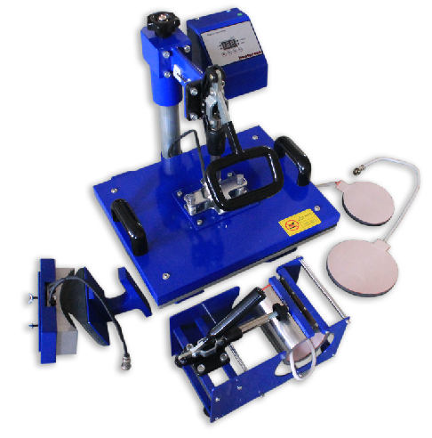
COMBO HEAT PRESS MACHINE
Operator’s Manual (CE)

This machine is not suitable for minors to use or food processing.

• General:
A heat press machine is the machine that presses a transfer onto an imprintable substrate. Using high temperatures and pressures for a certain amount of time, the transfer is permanently embedded into the product.
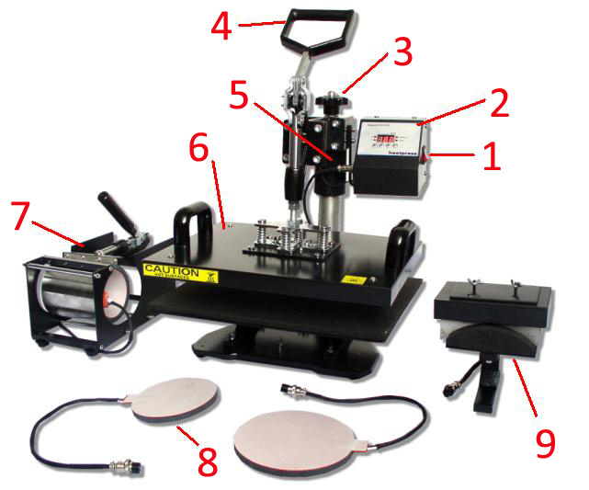
Heat presses are recommended for professional and satisfying results simply because standard laminating devices and home hand irons can not get even near the temperatures required for a reliable transfer.
•Components and functions:
- Power plug
- Temp/Time Gauge
- Pressure adjust screw

- Handle
- Connection plug
- T-shirt heating plate
- Mug press attachment
- Plate press attachment
- Cap press attachment
• Installation:
•Connect different connection plug
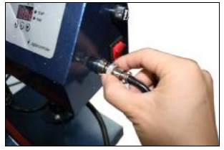
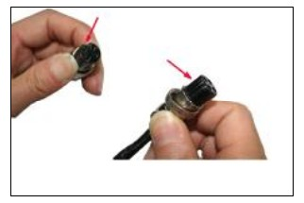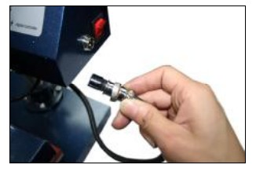
There is a slot in the connector Insert the connector in power plug Screw the head of connector•Change different heating elements
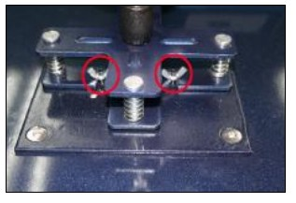
Loose the screws
1.Install plate press attachment
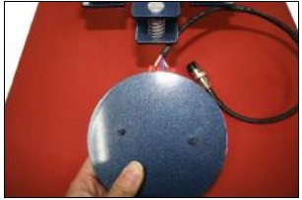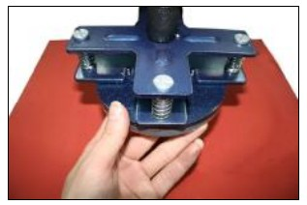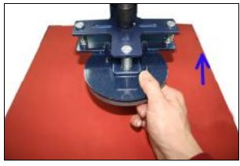
The end of wire towards the machine Fix it under the handle Push it to end,no need lock as it with magnet
2.Install cap press attachment
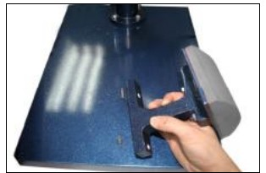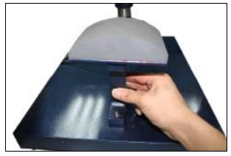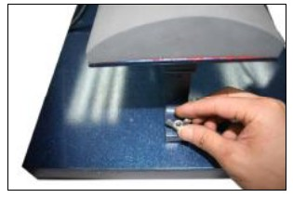
Longer end of base towards machine Place it on the machine base Lock the screws
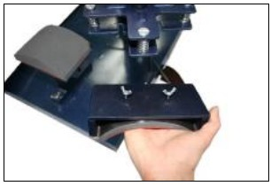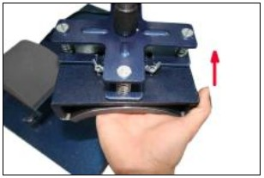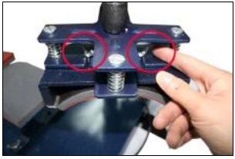
Fix the top cap heating plate Push it to the end Lock the screws

2.Install mug press attachment
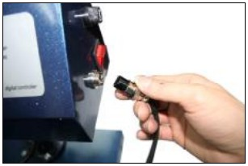
Connect the mug connector
1.Set temperature
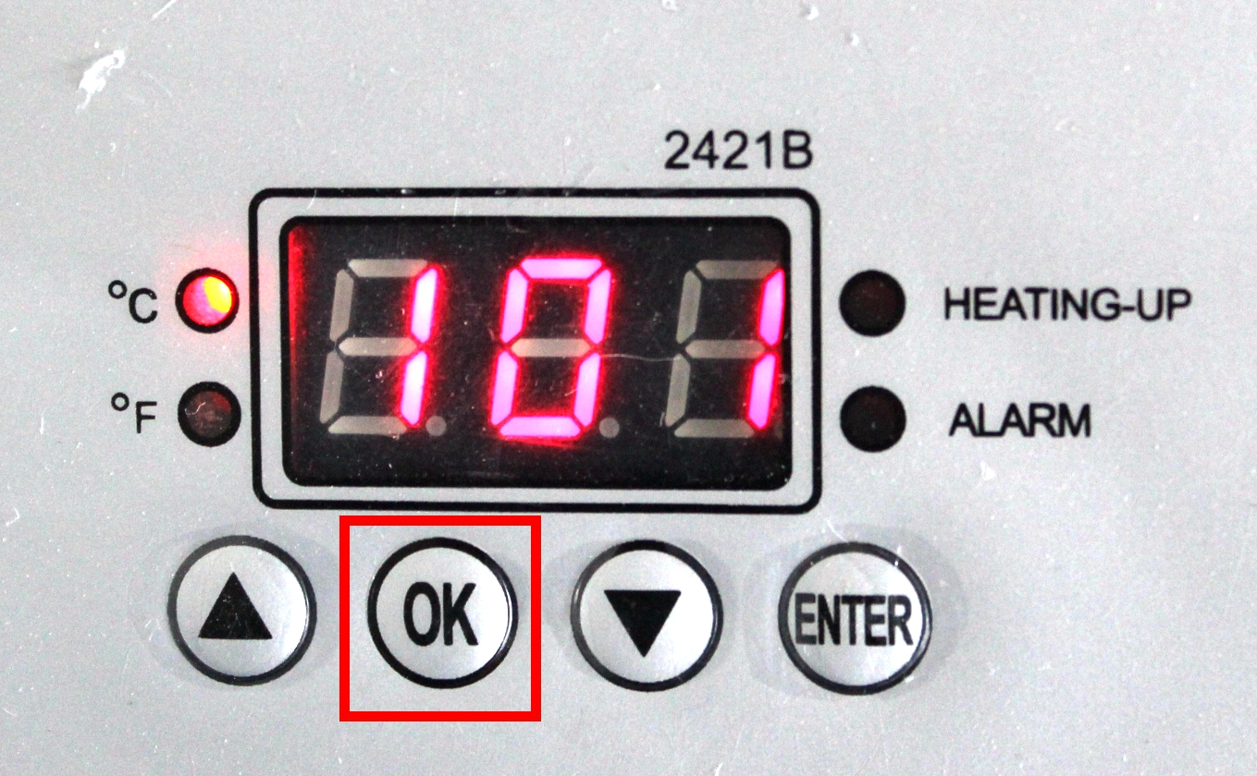 | 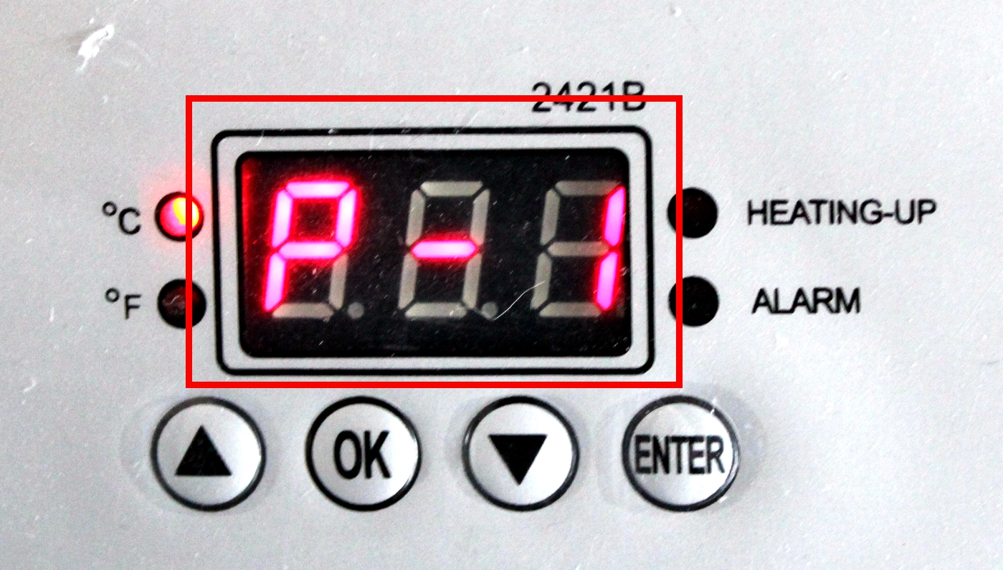 | 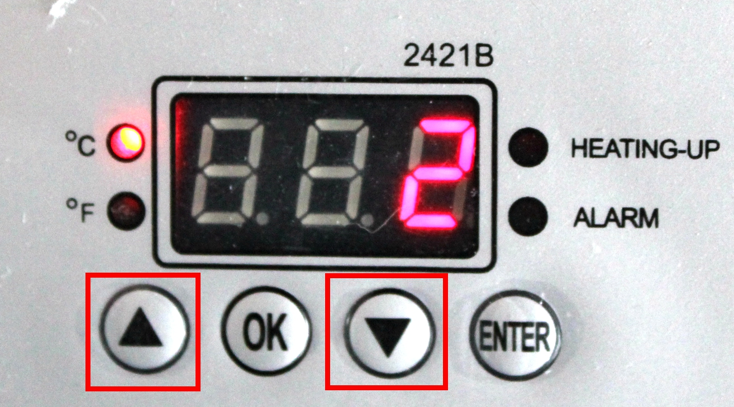
Press OK button | The display show P-1 | Press arrows “△”or “▽” adjust temp you need

Set time
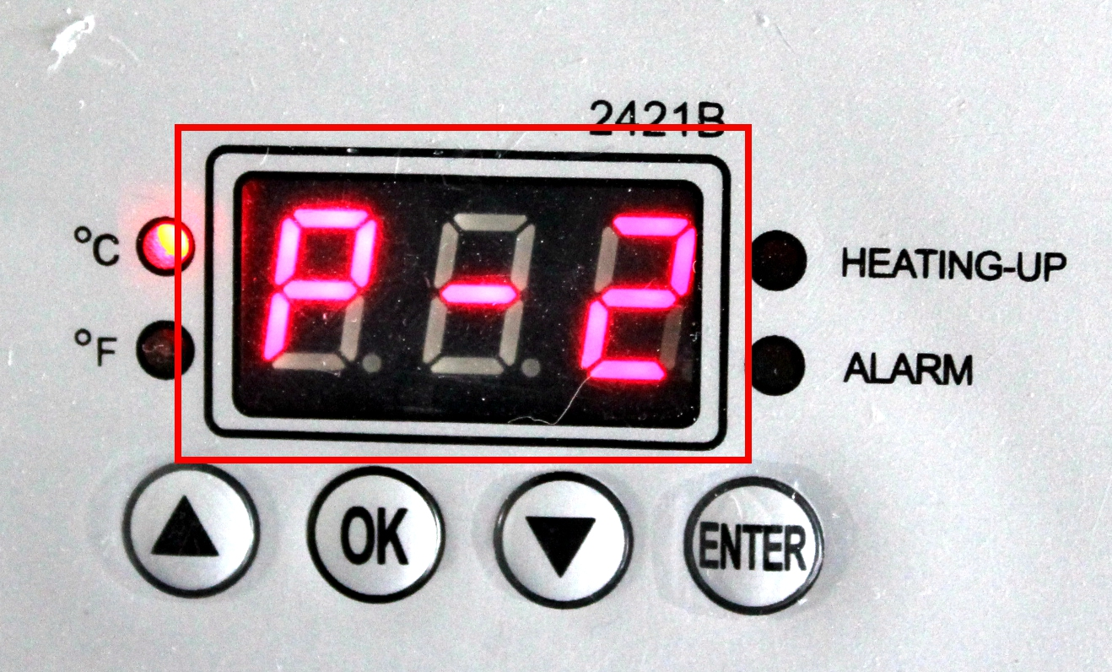 | 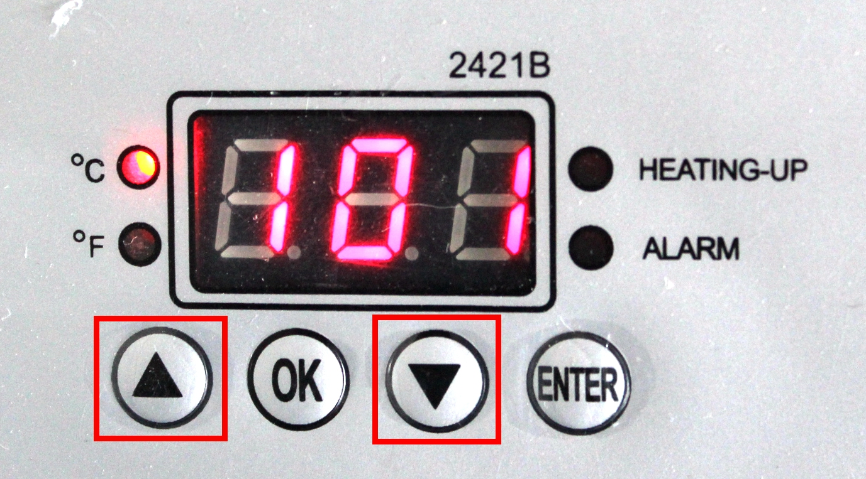 | 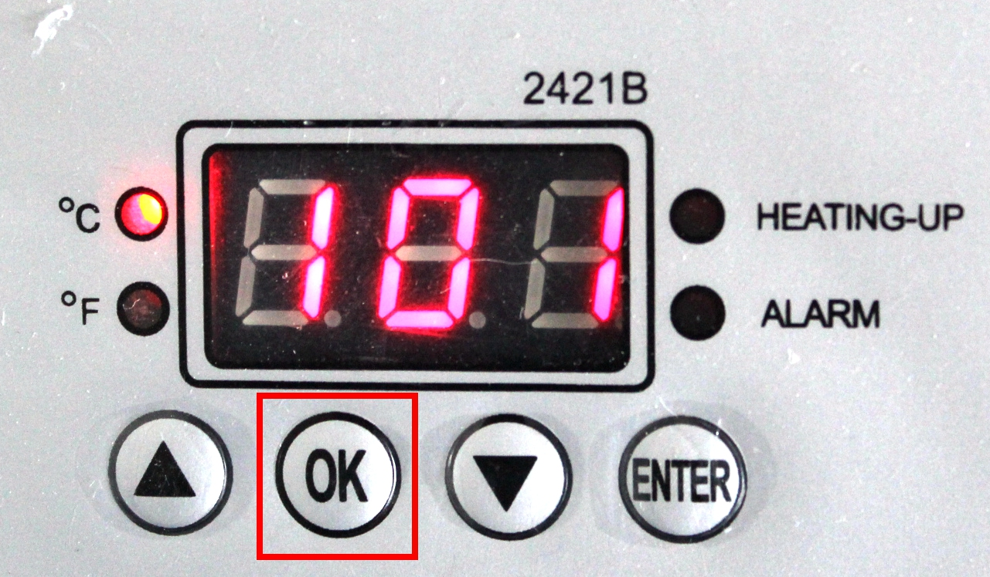
Press OK button after setting temp,display show P-2 | Press arrows “△”or “▽” adjust time you need | Press OK button after time setting
Note: 1.Because the materials are different,so the temp and time also required different.Clothing require temp about 180℃,Fabric clothing use with sublimation paper:30-50 sec,100% cotton clothing use with transfer paper:15-20sec.Ceramic products like tile,plate,mug temp about 180℃,time about 200S-300S.Cap temp about 180℃,time about 30S-40S.
2. Pls try a small sample to get the right temp and time needed before large quantities printing.

 | Problem | Cause | Handling methods
1 | Picture burning | Too much time or temp | Adjust time or temp.
2 | Fails to heat up,but display well | Heating plate or Relay broken | Check the heating plate or Relay
3 | Lack of color, faded image. | Insufficient temperature  and/or press time. | Adjust the temperature  and/or increase the heating time.
4 | Darkened, deep color; blurred image. | Pressed for too long,temperature too high | Adjust the temperature and  heating time.
5 | No action after turn on power | Plug whether touch well  Fuse whether burn | Check the plug and fuse
6 | The real temp pass over setting temp | Relay broken | Replace the relay

